NAME: SHENDYE VEDANG UPENDRA
MIS:112315171
PYTHON ASSIGNMENT 3
DATE: 21 AUGUST 2024

QUESTION 1:
Write a program to count the numbers of characters in the given string and store them in a dictionary data structure.

CODE:
str=input("enter a string")
mydict=dict()
for i in str:
if i not in mydict:
mydict[i]=1
else:
mydict[i]=mydict[i]+1

print(mydict)

OUTPUT:
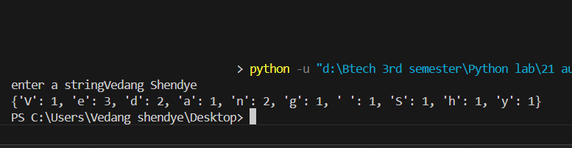

QUESTION 2:
Write a program to use split and join methods in the given string and trace a birthday with a dictionary data structure.

CODE:
str=input("enter your birth date: ")

str2=str.split("-")
str3=str.split("-")
print("\n\nthe entered birth date is:", "/".join(str2))

mydict=dict()

mydict["Day"]=str3[0]
mydict["Month"]=str3[1]
mydict["Year"]=str3[2]

#mydict["Year"]=str(int(mydict["Year"])+20)

print("I will turn 20 on: ",mydict["Day"],"/",mydict["Month"],"/",int(mydict["Year"])+20)Output:
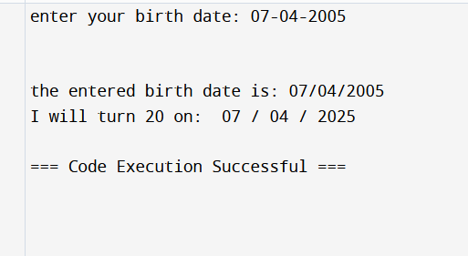

QUESTION 3:
Write function to compute gcd and lcm of two numbers.

CODE:
a=(int)(input("enter first number"))
b=(int)(input("enter second number"))
hcf=1
lcm=a*b
for i in range(2,min(a,b)):
if a%i==0 and b%i==0:
hcf=i

print("the HCF of given numbers is: ",hcf)

for i in range(max(a,b),a*b+1):
if i%a==0 and i %b==0:
lcm=i
break
print("the LCM of the given two numbers is: ",lcm)

OUTPUT:
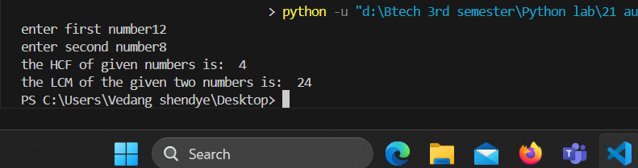

Question 4:
Write a function ball _collide that takes two balls as parameters and computes if they are
colliding. Your function should return a Boolean representing whether or not the balls are
colliding. Represent a ball on a plane as a tuple of (x, y, r), r being the radius. If (distance
between two balls centers) <= (sum of their radii) then (they are colliding)
Code:
import math
ball1=(0,0,5)
ball2=(12,13,4)

def ball_collide(a,b):
dist=(a[0]-b[0])*(a[0]-b[0])+(a[1]-b[1])*(a[1]-b[1])
dist=math.sqrt(dist)

if dist>a[2]+b[2]:
return False
else:
return True

answer=ball_collide(ball1,ball2)
print("the value of answer is: ",answer)

OUTPUT:
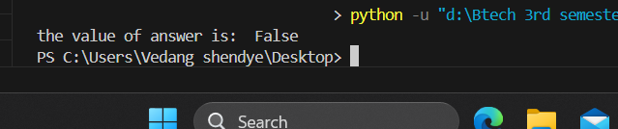

Question 5:
Code:
import statistics

data=[4,3,7,1,3,7,2,2,2,4,2,8,9,10,11]
print("the mean of the data is:",(statistics.mean(data)))
print("the median of the data is:",statistics.median(data))
print("the mode of data is:",statistics.mode(data))

OUTPUT:
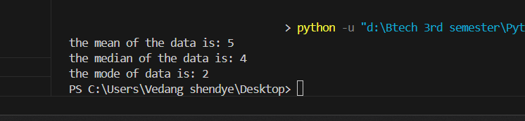

QUESTION 6:
Write a program to implement
a. Bubble sort,
b. Merge sort,
c. Selection sort and
d. Insertion sort.
Execute these sorting algorithms using switch case.

Code:

data=[1,5,7,6,3,2,8,9,10,11]

def bubble(arr,size):
for i in range(0,size):
for j in range (0,size-1):
if arr[j]>arr[j+1]:
temp=arr[j]
arr[j]=arr[j+1]
arr[j+1]=temp

# bubble(data,10)
# print("after bubble sort, array becomes:\n",data)

def mergesort(a, p, r):
if p < r:
q = (p + r) // 2
mergesort(a, p, q)
mergesort(a, q + 1, r)
merge(a, p, q, r)

def merge(a, p, q, r):
n1 = q - p + 1
n2 = r - q

left = [a[p + i] for i in range(n1)] + [float('inf')]
right = [a[q + 1 + i] for i in range(n2)] + [float('inf')]

i = 0
j = 0

for k in range(p, r + 1):
if left[i] <= right[j]:
a[k] = left[i]
i += 1
else:
a[k] = right[j]
j += 1

def insertion_sort(arr):
size = len(arr)
for i in range(1, size):
key = arr[i]
j = i - 1
while j >= 0 and arr[j] > key:
arr[j + 1] = arr[j]
j -= 1
arr[j + 1] = key

def selection(arr,size):

for i in range(0,size):
min=999999
minindex=0
for j in range(i,size):
if arr[i]<min:
min=arr[i]
minindex=i

temp=arr[i]
arr[i]=min
arr[minindex]=temp

inp=int(input("enter 1 for bubble sort,2for merge sort,3 for selection sort, 4 for insertion sort: "))

if inp==1:
bubble(data,10)
elif inp==2:
mergesort(data,0,9)

elif inp==3:
selection(data,10)

elif inp==4:
insertion_sort(data)

print("after sorting, array becomes:\n",data)

OUTPUT:
